
Online Remote Data Backup
Many companies still trust the backup of their most vital resource - data - to a fragmented and often ineffective policy of distributed tape devices, manual routines, and offsite tape storage. MBA Software Remote Data Backup is a business-class online backup service which addresses the drawbacks of this fragmented approach to backup with a unique service offering:

♦ Fully automated process with backups held on disk for rapid file restoration.
♦ Secure online transfer of fully encrypted data to an offsite data center, ensuring regular backups are stored safely and remotely.
♦ Sound basis for business continuity planning - whatever happens, your data is safe.
♦ Cost-effective solution with an all-inclusive monthly service charge ($20.00) & a one-time install fee.
♦ 24 x 7 live customer support

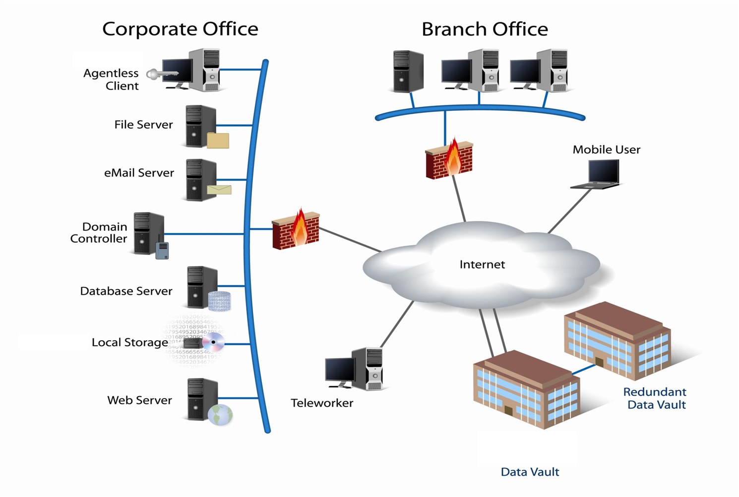
Technology Overview  ⋅ Agentless Client  ⋅ Compression  ⋅ Encryption  ⋅ Delta Blocking Incremental Backup  ⋅ In-file Deduplication  ⋅ Open File Backup  ⋅ Simple User Interface | Service Features  ⋅ Microsoft Exchange  ⋅ Microsoft SQL  ⋅ File Servers  ⋅ Laptop & Standalone Desktop  ⋅ Local Storage Backup & Restore Option  ⋅ Comprehensive Reporting  ⋅ Mirrored Data Centers

